**EXP NO: 05**

**DATE: 13-04-24**

**Aim:**

Create a simple cloud software application for Mark Sheet Processing System using any Cloud Service Provider to demonstrate SaaS include the necessary fields such as name of the student, Reg no of the student, Subjects, Marks, Average, percentage, rank, overall performance etc.

**Implementation:**

**1. Go to Zoho.com and login/signup**

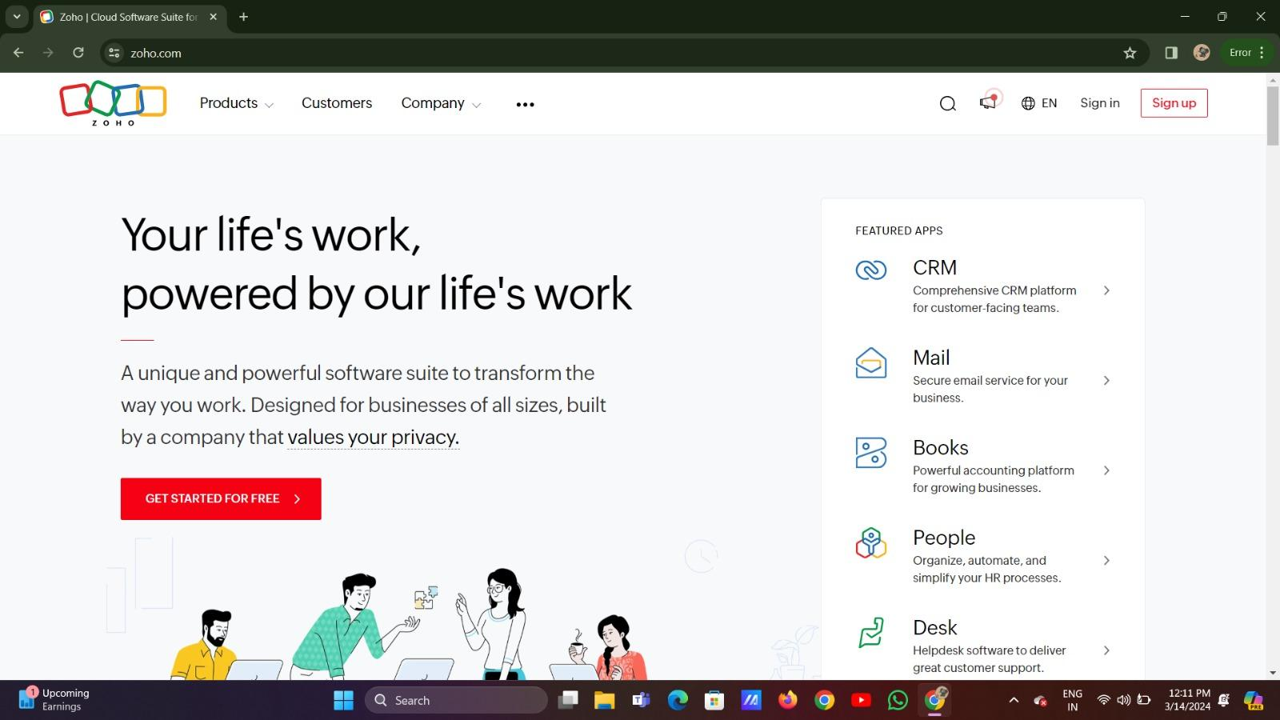

**2. Go to Creator**

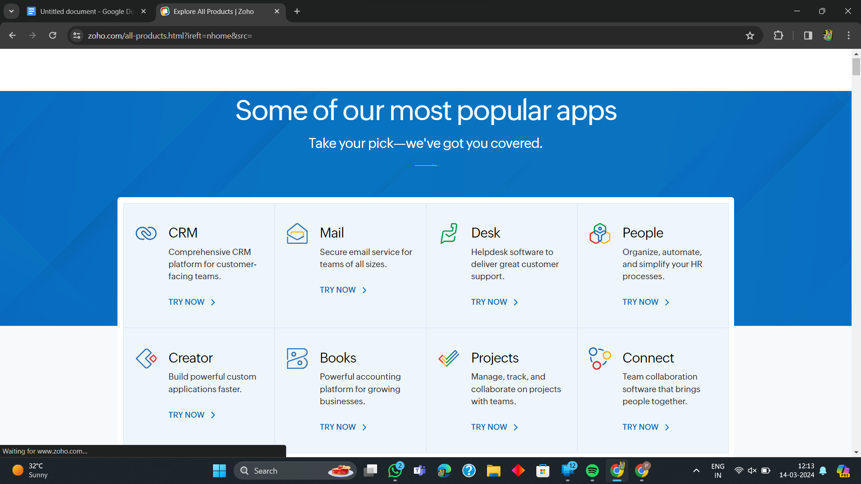

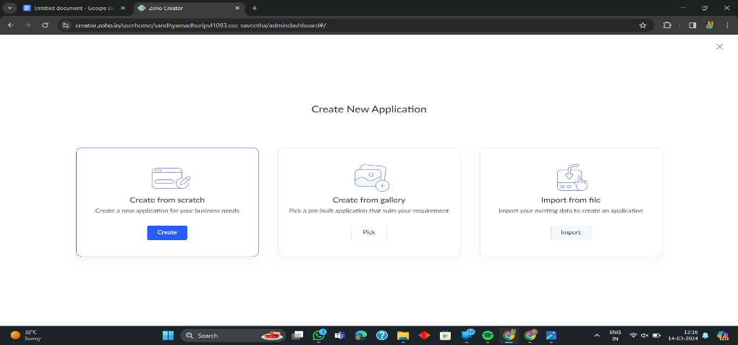**3. Create A New Application**

**4. Given Application Name**

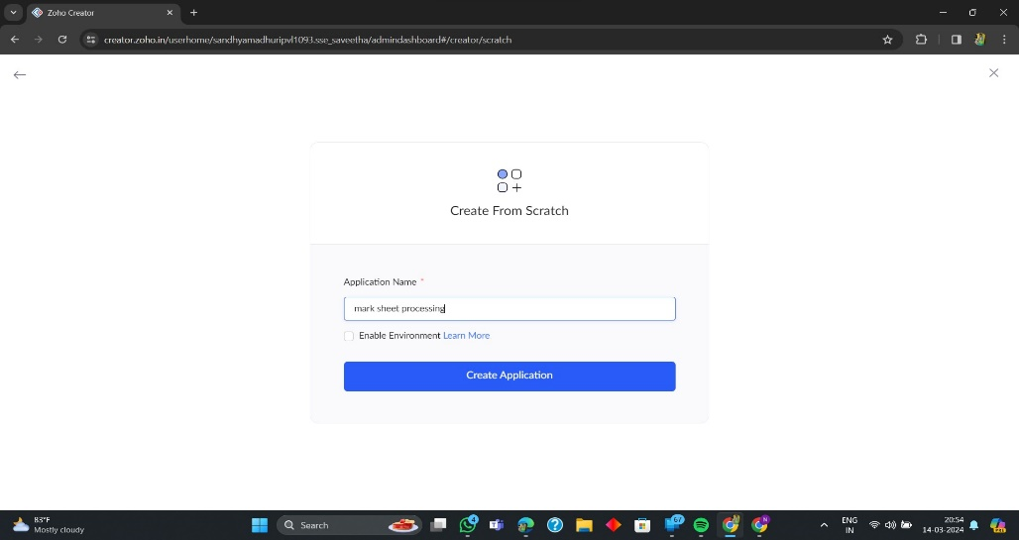

**5. Create New Form**

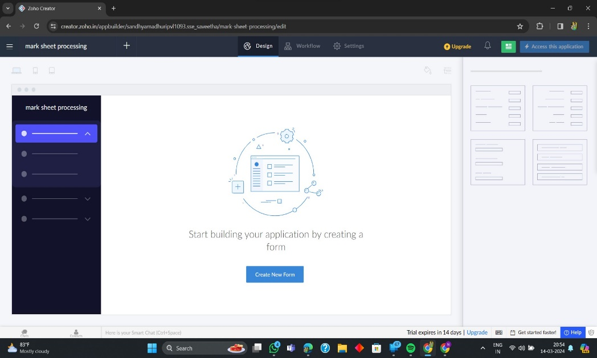

**6. Select Form and Give Name**

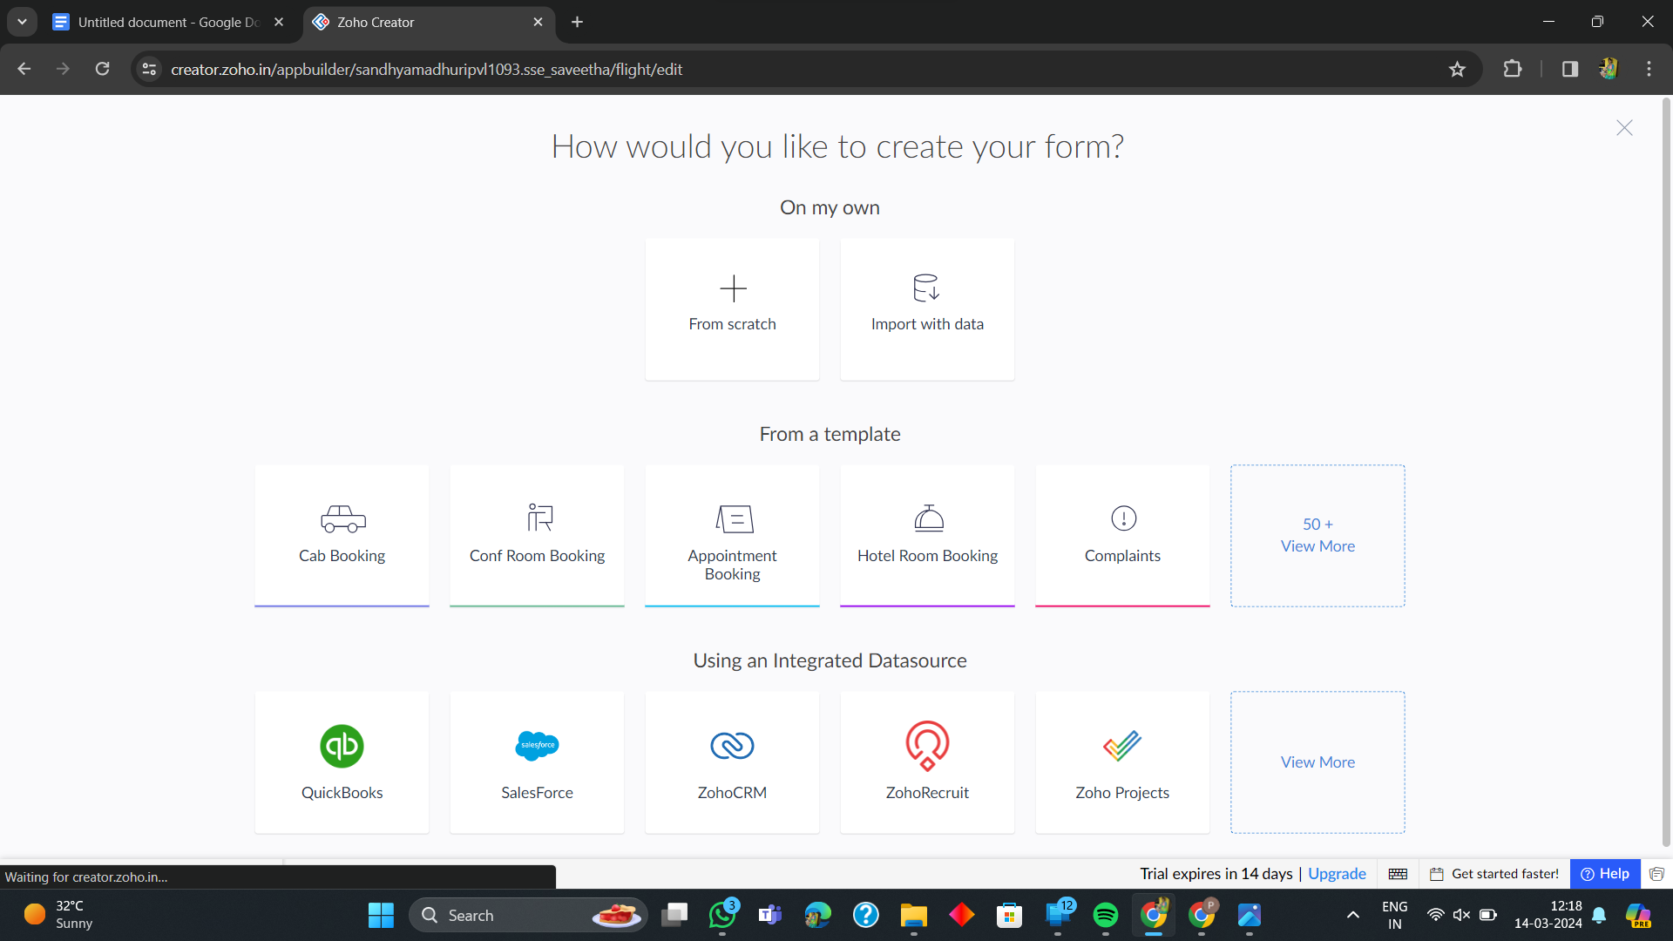

**7. Create from scratch**

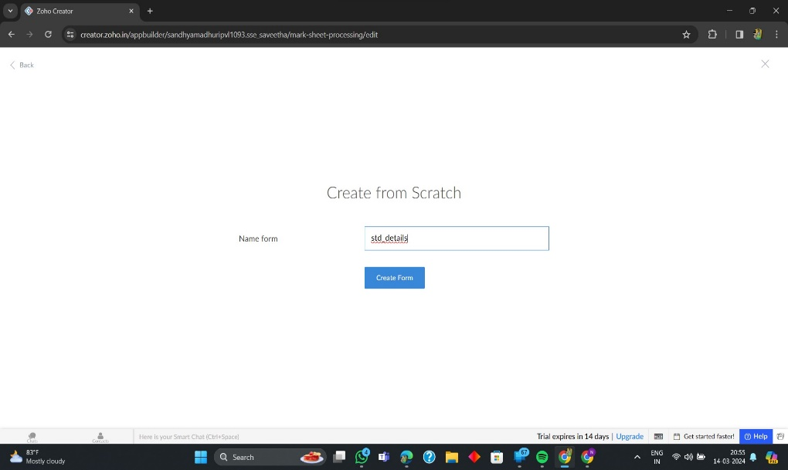

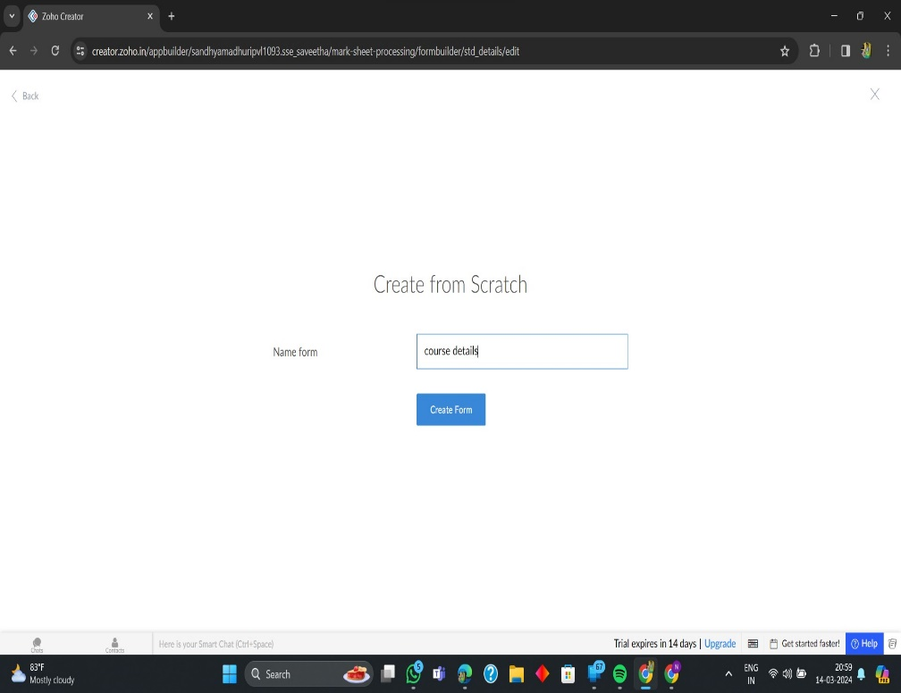

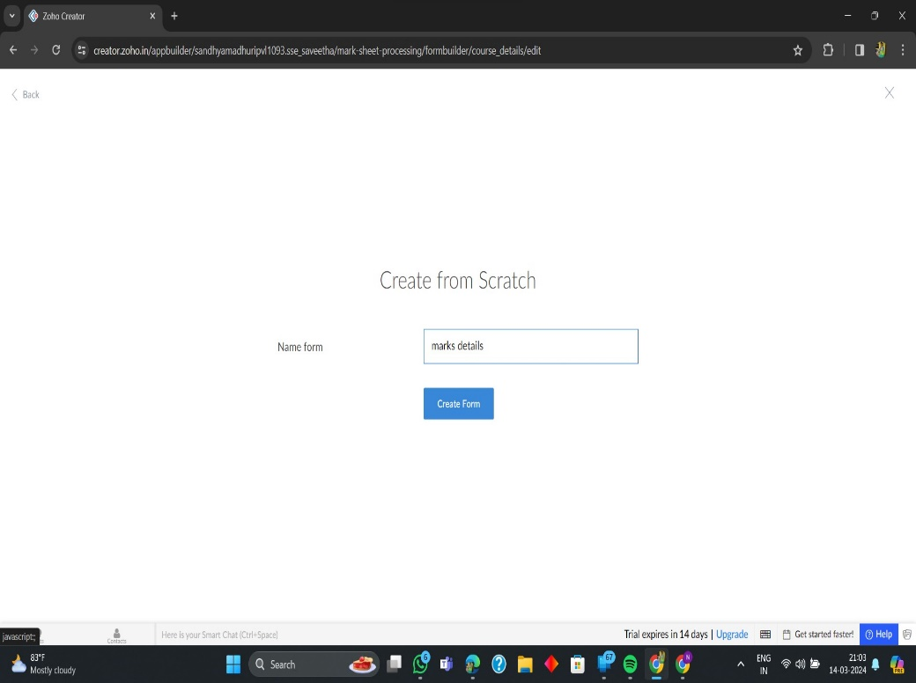

**8. The Software Has been created**

